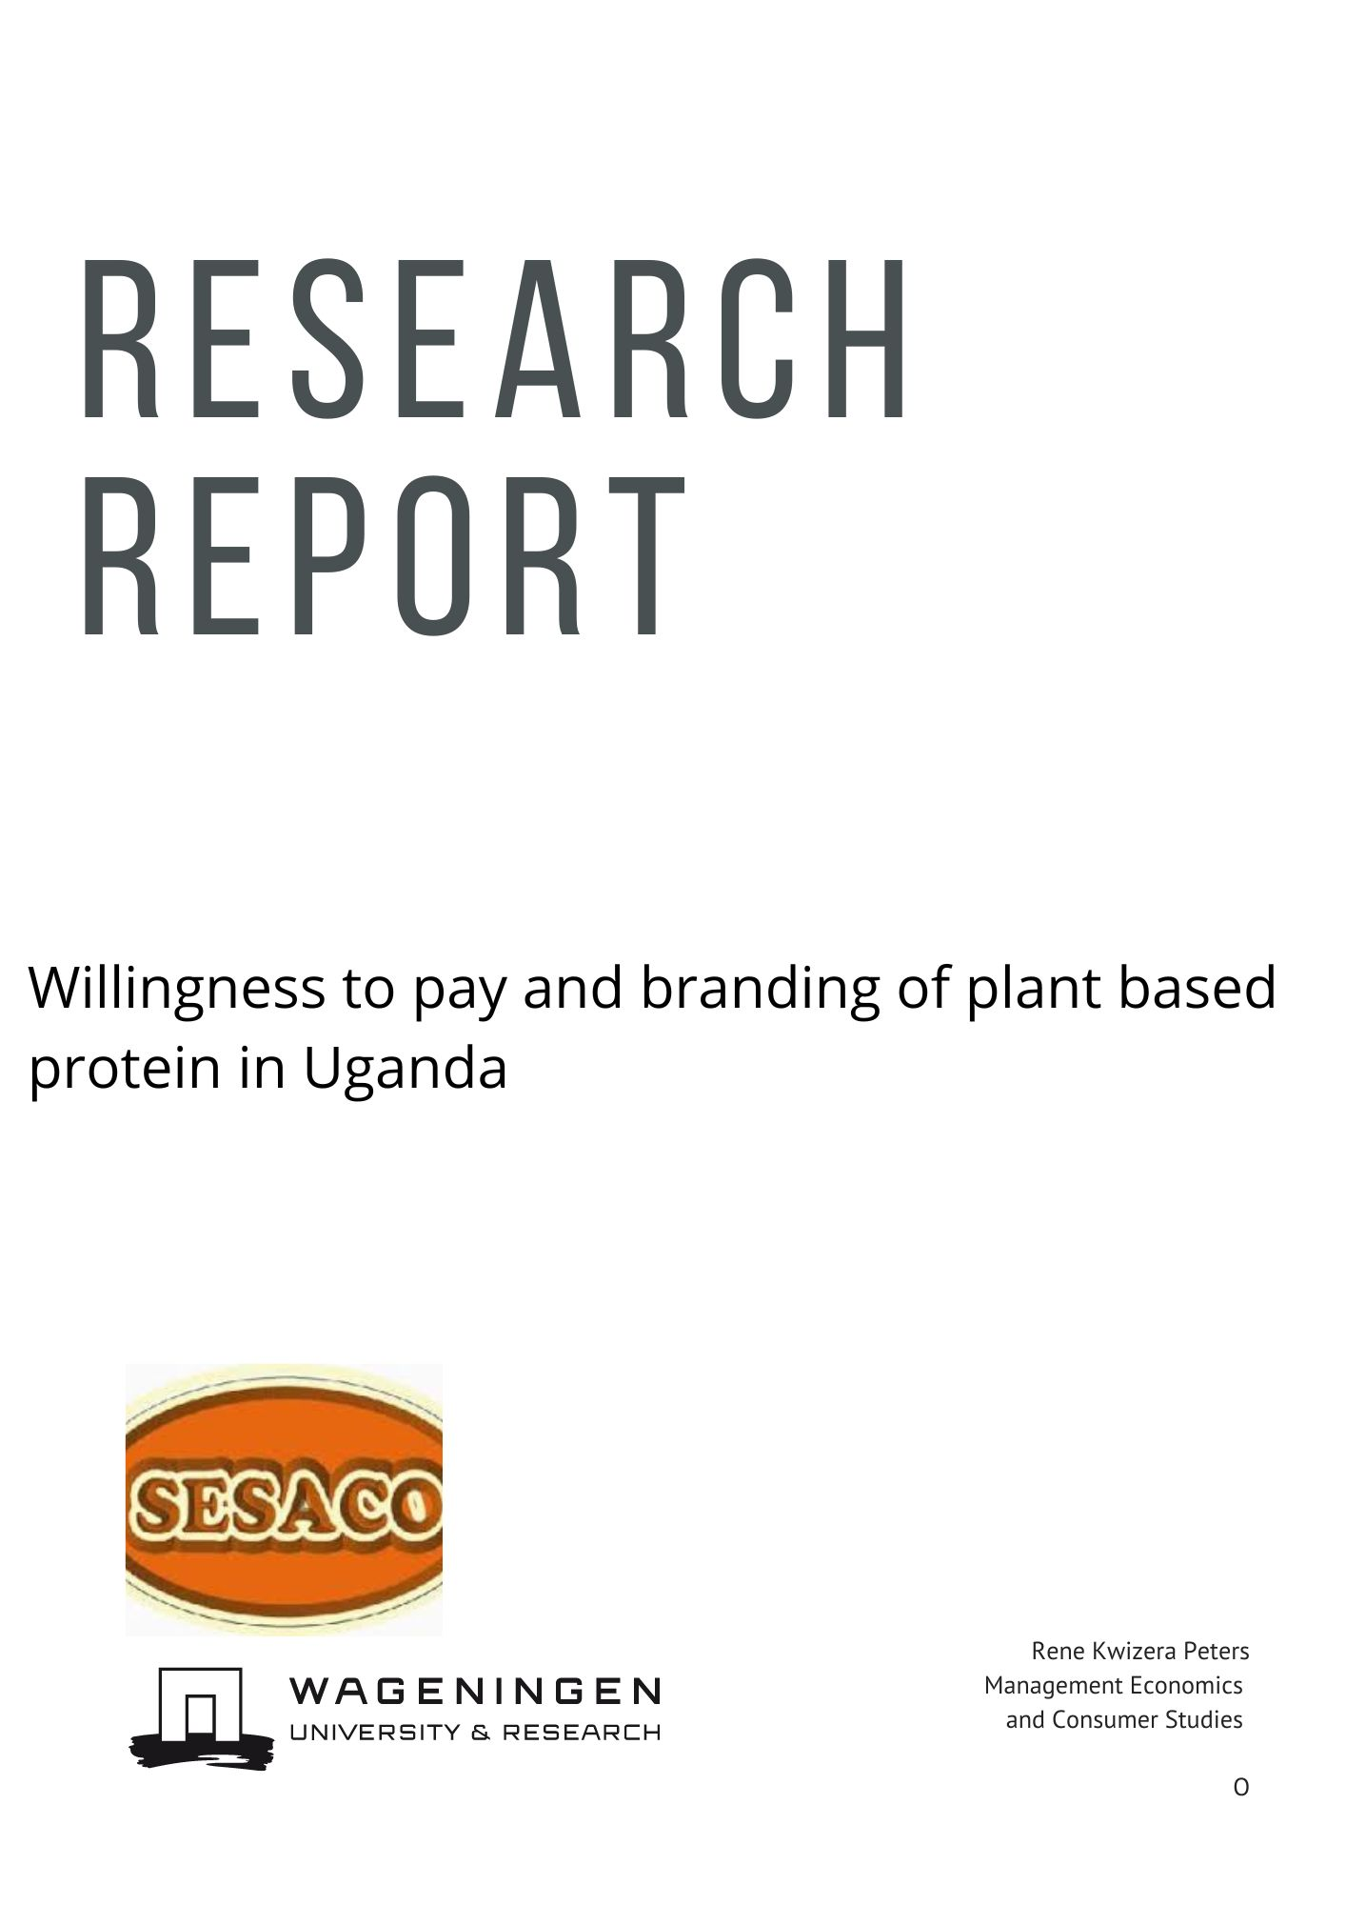**Abstract**

The report argues that plant-based proteins cannot be ignored in the fight against climate change. Human behavior plays a crucial role in both causing and responding to global climate change. The foods we eat have different environmental impacts, with plant-based sources requiring fewer resources than animal-meat. However, for companies to market plant-based protein to consumers we need to understand how branding affects consumers purchasing decisions. To this end it was studied to what extent different branding strategies effect the willingness to pay for plant-based protein menu items in Uganda. The study concludes that framing menu items as meat free reduces willingness to pay significantly, compared to branding that focuses on the general attributes of a menu item. There also seems a predisposition in the sample to value branding that emphasizes environmental impacts.

1. **Introduction**

As the global population and prosperity continue to increase, so does the demand for food. In response to this, there is a need to examine the potential for increasing plant-based protein consumption in Africa and more specifically Uganda, where food insecurity is still a concern. As such I argue that plant-based proteins cannot be ignored in the fight against climate change.

Human behavior plays a crucial role in both causing and responding to global climate change. The foods we eat have different environmental impacts, with plant-based sources requiring fewer resources than animal-meat. Agricultural practices, such as growing food, currently account for nearly 25% of global greenhouse gas emissions and 70% of fresh water use (Bacon & Krpan, 2018). Animal husbandry, in particular, according to Willet et al. (2019), is one of the leading causes of eutrophication, acidification, freshwater withdrawal, deforestation and climate change.

The marketing of plant-based proteins in Africa presents different challenges than in the West, where early adopters are accepting the health and sustainability benefits of plant-rich diets (Bryant, 2019). A study by Baltussen et al. (2006) found that organic products were able to command a 60% price premium over less sustainable competitors. However, it is unknown if these findings can be generalized to African consumers. Attitudes towards sustainable food choices are influenced by culture and the food environment, and further research is needed to understand these attitudes and behaviors. Changing dietary habits, however, presents multiple challenges. Consumers may claim that their dietary choices are based on functional attributes, but this is not always reflected in their actual decisions (Bucher, et al., 2016).

Therefore, the objective of this study is to investigate the effect of plant-based proteins on consumers' willingness to pay for menu items in Uganda. For this purpose I use the Van Westendorp price sensitivity model. To date, little academic attention has been paid to dietary habits and attitudes towards vegetarianism in developing countries (Clayton, et al., 2015) (Stern, Contributions of psychology to limiting climate change, 2011). However, the importance of these countries in the fight against climate change cannot be ignored. Emerging markets make up 65% of the world's population and are expected to grow three times faster than developed economies (Aithal, Satyam, & Maurya, 2018). As a result, African consumers are expected to drive most of the future increase in demand for animal protein. The literature on marketing vegetarian diets in Africa is almost non-existent, possibly due to a lack of urgency. The global poor face many challenges, and promoting vegetarian diets may not be considered a priority.

*The hypothesis: is that Ugandan consumers value the environmental aspects of their diet choices differently than those in the West. In Uganda, vegetarianism may not be seen as a valid reason to pay more for a meal, and meat may be perceived as a necessary component of a healthy diet. As a result, framing menu items as vegetarian may actually lower consumers' willingness to pay.*

**2. Background**

In this chapter I summarize the state of protein production systems with regard to nutrition, environment and supply constraints in Uganda and Africa. For animal farmed meat, and plant-based meat alternatives. To inform the reader about the discussion regarding plant-based meat versus animal farmed meat systems environmental impact and nutritional importance.

*Ugandan diets and protein*

Protein deficiency is a widespread problem across Africa, including in Uganda. The protein intake in Uganda is inadequate in both quantity and nutritional quality, leading to stunted growth and impaired cognitive ability (Schonfeldt & Hall, 2012). Protein is a crucial component of a healthy, balanced diet, and the quality of protein in diets varies. Ugandans mainly consume protein from starchy crops like maize, which is of lower quality than animal-based proteins like meat, milk, and eggs. This lack of protein in the diet leads to protein malnutrition, with one-third of children under the age of five suffering from it (FAO; IFAD; WFP, 2013).

Protein quality is normally classified in terms of protein digestibility-corrected amino acid score (PDCAAS), which is a measure of its essential amino acid profile and digestibility. Higher PDCAAS means a better digestible amino acid profile, with 1.00 being the highest score. Textured soy protein chunks have a published PDCAAS of 0.95, beef for instance has a PDCAAS’s of 0.92 (Impossible foods, 2022). As population, income, and urbanization all increase the demand for nutritious protein, there is a nutritional gap in Uganda between the food that is available and the food that is needed for a healthy diet. Plant-based meats could play a role in filling this gap, as they offer a good nutritional profile, are affordable, and have a lower environmental impact compared to animal-based proteins.

*Concerns with animal protein in Uganda*

In Uganda, there are several concerns surrounding the increased consumption of animal-based protein. The first major concern is that the current protein supply systems may not be able to keep up with the expected increase in demand. As the population grows and incomes rise, there will be a greater need for protein sources to meet the nutritional needs of the population. This will require an expansion of protein production systems, which may be difficult to achieve in a sustainable manner (Mottet, et al., 2017).

Second, animal protein has more food safety concerns than plant-based protein (Szejda, Stumpe, Raal, & Tapscott, 2021). There are several reasons why animal protein may have more food safety concerns than plant-based protein. One reason is that animals are more likely to carry diseases and bacteria that can be harmful to humans. This is because animals are often raised in crowded and unsanitary conditions, which can lead to the spread of illness. Additionally, meat and other animal products can become contaminated during the processing and handling stages, which can increase the risk of food poisoning (Hoppe, Molgaard, & Michealsen, 2006). Additionally, the use of antibiotics and other drugs that are used to treat illness in animals. These drugs can remain in the animal's tissue, and when the animal is consumed by humans, the drugs can be transferred to the human body. This can lead to antibiotic resistance and other health problems (Dror & Allen, 2011). Further neighbors who live in the vicinity of farms face elevated risks of respiratory outcomes, stress, negative moods, and infections to zoonotic pathogens (Casey, Kim, Larsen, & Nachman, 2015).

In contrast, plant-based protein sources are typically not associated with these types of food safety concerns. Plants are less likely to carry diseases and bacteria, and they are not routinely treated with antibiotics or other drugs. This makes them a safer and healthier option for those who are concerned about food safety (Auma, Pradeilles, Blake, & Holdsworth, 2019) (Santo, et al., 2020).

Third, the production of animal protein is resource-intensive compared to plant-based alternatives. Animal farming requires large amounts of land, water, and energy to produce meat, and it can also produce significant amounts of greenhouse gas emissions. This can have negative impacts on the environment and contribute to climate change. Livestock production accounts for an estimated 14.5 percent of global greenhouse emissions (Santo, et al., 2020). Meat and dairy from ruminants, such as cows and goats, is especially greenhouse gas intensive. Roughly half to three-quarters of agricultural land is devoted to farming meat. With estimates ranging from 2.5 (Mottet, et al., 2017) to 3.7 (Foley, et al., 2011) billions of ha devoted to the animal meat production system. This while from a calorie consumed perspective animal sources only cover 18% of calories and 25% of protein in the global food supply. The large land footprint is caused by the large feed and forage required to produce an equivalent number of calories and protein from meat. The land use could be drastically reduced if we consumed the calories and protein directly from plants grown for human consumption.

Overall, there are several concerns surrounding the increased consumption of animal-based protein in Uganda, including the potential for food safety issues, resource-intensive production, and negative environmental impacts. These concerns should be carefully considered as the demand for protein increases in the country (Szejda K. , Stumpe, Raal, & Tapscott, 2021).

*Textured soy protein*

There exist a variety of products that try to approximate and or even replicate certain aspects of meat’s texture, flavor, and nutrient profile. Textured soy protein is only one of them. Soybeans contain about 35-40% protein on a dry-weight basis and provide a full amino acid profile, studies have shown (Young, 1991) that well-processed soy-protein can serve as the major, or even sole, source of protein intake. Effectively showing that soy protein value is essentially equivalent to protein acquired through meat consumption from animal origin.

Textured soy protein refers to defatted soy flours which go through a process called extrusion cooking. Due to the extrusion cooking, where the defatted soy dough is cooked and by passage through an extrusion screw with superheated steam, a textured similar to grounded meat is created. This process creates a spongy, fibrous texture that resembles ground meat. The ground meat can then be sliced by a knife into granules, flakes, chunks, goulash, and steaks (Asgar, Fazilah, Huda, Bhat, & Karim, 2010). Textured soy flakes in general contain comparable amounts of calories, protein, and iron as the meats they are intended to replace. Extruded soy protein has a similar nutritional profile to animal-based meat, with comparable amounts of calories, protein, and iron. It also has several advantages over animal-based meat, including a lower environmental footprint and reduced animal welfare concerns.

There are several reasons why plant-based protein can be advantageous nutritionally. For one, plant-based protein sources are often lower in calories and fat than animal protein sources, which can be beneficial for weight management and overall health. Plant-based protein sources also tend to be rich in fiber, vitamins, and minerals, which can help support a healthy digestive system and overall nutrient intake. In addition, they have also been associated with improved blood lipid levels and lower risk for cardiovascular problems (Malav, Talukder, Gokularakrishan, & Chand, 2015). There have been studies that suggest better health outcomes but it is a recent field. Studies suggest that replacing animal based meat with plant based protein improves bone health, reduces menopausal symptoms, reduces the risk for type 2 diabetes and modestly decreases the risk for breast cancer (Zhang, Zao, Du, Zhou, & Chen, 2020) (Anderson, Johnstone, & Cook-Newell, 1995) (Tang, et al., 2020).

One of the main things in favor of higher use of plant-based meat dietary proteins is their environmental footprint. The environmental footprint depends mainly on two stages, the land use needed for growing and the inputs needed for processing. Land use from a calorie and protein perspective is up to 98% lower compared to meat from beef herds, 89% lower than beef from dairy herds and 77% lower compared to meat from poultry, resulting in less biodiversity loss and deforestation. Regarding greenhouse gasses the median greenhouse gas emission of 100g of plant-based substitutes was 43% lower compared to poultry, 63% lower compared to pork, 72% lower compared to farmed crustaceans, 87% lower compared to dairy herds, and 93% percent lower beef from meat herds (Santo, et al., 2020).

**3. Theoretical framework** In this chapter I discuss the theoretical frame used in the empirical research. First, the theories underpinning the van Westendorp price sensitivity meter. Hereafter, food decision making heuristics and lastly food neophobia will be discussed.

*Willingness to pay*

Price can be an impediment to substitute animal protein for plant-based proteins (Wei, Ang, & Jancenelle, 2018). The use of the van Westendorp’s price sensitivity meter (PSM) can help determine the optimum price for plant-based protein products. This method measures the reservation price of a product, which is the maximum amount a consumer is willing to pay for it. By understanding this price point, food developers and managers can set the retail price of their plant-based protein products in a way that maximizes their economic sustainability and consumer satisfaction. This method is widely used because it is easy to implement and does not require a lot of data collection. By using the van Westendorp’s PSM, companies can ensure that their pricing strategy is informed and effective in encouraging consumers to switch to plant-based protein products (Weinrich & Gassler, 2021). Due to its ease of use, and modest requirements regarding data collection this study uses the van Westendorp PSM. Its measure of the reservation price is based on the hypothesis that each potential buyer of a product is willing to pay a maximum price which is the monetary equivalent to the consumers gained utility by the product. In other words, the optimum price point using the willingness to pay (WTP) is the price where the consumers are indifferent between buying the product and forgoing the transaction. The WTP is obtained from consumers answers or stated preferences. The model assumes that there exist reasonable prices for consumers in every category and for perceived levels of quality. As such consumers pricing decisions are made by balancing value against price; and there is an upper and lower bound price the consumer is willing to pay for a product or service. To this end, the PSM involves direct questioning. It asks for the following four different price points:

1. At what price do you consider the product to become inexpensive but you would still consider it to be a bargain? (Cheap)
2. At what price do you consider the product to become expensive but you would still consider buying it? (Expensive)
3. Above what price would the product become too expensive so that you would not consider buying it? (Too expensive)
4. Below what price would the product become so inexpensive that you would doubt its quality and not consider buying it? (Too cheap)

Responses to these questions are prices whose frequencies are cumulated and plotted for analysis, see figure 1.

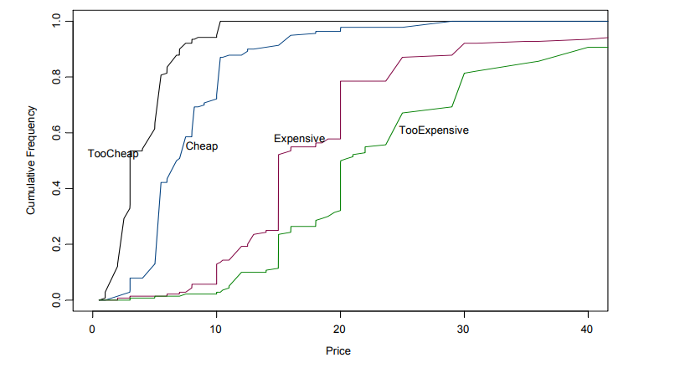

Fig 1. Cumulative frequency

Van Westendorp’s PSM considers a combination of these curves and their intersections. This results in 4 plotted curves of which 2 curves “not cheap” and “not expensive” are the reverses of the “cheap” and “expensive” curve. This allows for the identification of 4 critical price points that can be inferred from the intersections of the curves. The four intersections are the point of marginal cheapness (PMC), this is the price at which the same proportion of respondents experience the product as “not cheap” and “too cheap”. Secondly, the point of marginal expensiveness (PME). Which is the price at which the same proportions of respondents experience the product as “not expensive” and “too expensive” Thirdly, the optimal pricing point (OPP). Where the proportions of respondents deeming the product as too expensive and too cheap are the same. And fourthly, the indifference point. This can be considered as the normal price at which proportions of respondents that feel the product is cheap and expensive are the same. See figure 2 for an example from Kunter (2016).



Figure 2. Van Westendorp willingness to pay

The acceptable price range for a product lies between the points of marginal cheapness and marginal expensiveness. The optimal pricing point is considered the best price one can set.

*Heuristics and choice architecture of food choices*

Nudging is a form of environmental intervention that seeks to influence people's behavior in a predictable way by altering the context in which they make decisions. This can be done in a subtle and unobtrusive manner, without restricting options or changing economic incentives (Thaler & Sunstein, 2008). Nudges are often focused on the automatic, unconscious decisions that people make, such as the order in which options are presented or the default option offered. By changing the "choice architecture" in which people make decisions, nudges can encourage people to make better choices without them feeling restricted or dissatisfied. Thaler and Sunstein (2008) show that we can change the choice architecture people experience and refer to it as managing the structured context in which people make decisions. Cambel, Arvai, and Kalof (2012) describe nudges as small asymmetric interventions in motivating choices with positive outcomes. Summarizing, nudges are inconspicuous interventions in the environment in which the consumer makes a choice that change the choice outcomes.

A study conducted by Wansink and Sobal (2007) studied food related decision making and how the environment influences these decisions. Concluding consumers are often not aware of the environmental drivers regarding making food choices. Food choices are most of the time guided by fast, automatic and cognitively effortless responses, or heuristics. Heuristics are mental shortcuts that facilitate problem solving, not guaranteed to be optimal, perfect or rational, but nevertheless sufficient for reaching an immediate, short-term goal or approximation. This fast heuristic-based choice architecture surrounding food decisions partly explains the attitude-behavior gap also called the value-action gap. The attitude-behavior gap is the finding that values or attitudes sometimes do not correlate to actions. The gap is found in multiple studies (Vanderbroele, Vermeir, Guens, Slabbinck, & Kerckhove, 2019). The studies have repeatedly shown that even though consumers have positive predispositions regarding sustainability these dispositions do not result in behavioral change. Thereby illustrating that food choices are not analytical nor classically rational. Nudging as such accounts for the choice architecture and aligns with the actual food consumption decision making process. Efforts to encourage consumers to eat in a sustainable way focusing on education and improving knowledge among consumers as such have had limited success (Vanderbroele, Vermeir, Guens, Slabbinck, & Kerckhove, 2019). This is because they did not account for the choice architecture by which consumers make their food choices.

Since studies show that choice architecture surrounding food choices are heuristics based this thesis assumes that different menu framing can alter the consumer's choice environment and nudge their behavior. We talk about framing when some facets of reality are made more salient in a communicating text (Entman, 1993). Reframing a menu description is one way to nudge people's behavior. By highlighting certain aspects of the food options, the menu can influence people's choices and guide them towards making better decisions. The expectation is that by making certain aspects more noticeable in a menu description one can nudge the audience towards a predictable behavioral change.

Turnwald et al. (2017) tested whether using indulgent words for healthy food items had an effect on food choice. They conducted this study in a large university cafeteria and showed that reframing the names of vegetables to make them more attractive made people choose more vegetables for their lunch. This technique has been validated beyond the consumption of vegetables. Studies regarding norm activation have shown that framing choices in such a way that they emphasize the connection between behaviors and salient values can remind people to engage in actions that benefit the environment. The seminal experiment by Kahneman and Tversky (1984) for instance had respondents imagine to prepare for a disease outbreak. They showed that people are more loss averse depending on the wording. Their first question was about saving people, followed by a question that was framed as a choice about letting people die. The questions both had the same material consequences but respondents reported vastly different answers depending on the wording. Turnwald et al. (2019) showed that reframing menus to include words associated with enjoyment in dish names can increase vegetarian choice. As such framing can play a role in stimulating consumers to make pro environmental food choices.

Overall, framing menu descriptions can be a powerful tool for influencing consumer behavior. By highlighting certain aspects of the food options and making them more salient, people are more likely to be nudged towards making a particular choice. This can be an effective way to promote healthy and sustainable food choices without restricting people's options or changing the economic incentives they face.

*Food neophobia scale*

The reluctance of some consumers to accept recipes, production processes or ingredients new to them can be measured by the food neophobia scale (FNS). Food neophobia, or the fear of trying new foods, could influence Ugandan consumers' willingness to pay for plant-based protein. Many Ugandans may be hesitant to try plant-based protein because they are new and unfamiliar to them. They are accustomed to consuming animal-based protein and may be unsure about the taste and texture of plant-based protein. This fear of trying new foods can make them less willing to pay for plant-based protein, as they may perceive it as being less desirable or less satisfying than animal-based protein. Additionally, food neophobia could also lead to consumers being more risk-averse and less willing to try new products, which can further decrease their willingness to pay for plant-based protein.

The FNS was developed by Plinner and Hobden in 1992 to measure food neophobia (FN). For this study the original FNS was adapted to a 5-item scale in which each item was rated on a 5-point Likert scale see table 1.

Table 1: 5-point Likert scale to measure food neophobia

|  |
| --- |
| Food Neophobia scale (FNS) |
| I am afraid to eat food I did not eat before. |
| I do not trust new food. |
| I constantly try new foods |
| I am very particular about the food I eat. |
| I eat almost anything (reversed) |

FNS has been used to study the effect of FN on the acceptance of products created with using novel technologies. FNS has also been extensively (Barton & Richardon, 2020) used often for evaluating the effect of neophobia in the consumer acceptance of plant-based products. These studies show that there is a relationship between higher FNS scores and lower intake of plant-based proteins (Rabadan & Bernabeu, 2021) (Campbell-Arvai, Kalof, & Arvai, 2012).

*Willingness to pay and framing: An adaptation of the value-attitude-behavior model*

By carefully framing menu items to align with consumers' values, restaurants and food producers can influence consumers’ willingness to pay for plant-based protein. Values in the value-attitude-behavior model are defined as a stable belief that facilitates a consumer to conduct a particular action that he or she prefers. Hereby modeling how different consumer attitudes result in different behaviors. The perceived importance level of a value influences how a person evaluates selected behaviors. The value-attitude-behavior model was proposed and tested by Homer and Kahle (1988). So, the value-attitude-behavior model explains how values are fundamental in the formation of attitudes which lead to a specific behavior in this case willingness to pay for a meal based on plant-based protein.

Research has shown a relationship between values and food consumption (Hansen, 2008). This also holds for values regarding environmentalism and food consumption choices (Verplanken & Holland, 2002) (Visschers & Siegrist, 2015). Showing a relationship between environmental concerns and a higher willingness to pay for food items that are framed as environmentally conscious choices. Research has shown that western consumers are willing to pay more for products with “organic”, and “fair-trade” frames (Pelsmacker, Driesen, & Rayp, 2005). Consumers were also shown to pay more for products with organic certification (Janssen & Hamm, 2012). Showing that the environmental frame addresses environmental virtues and as such influence behavior. If this extends to Ugandan consumers is unknown. There has been research in South-Africa which indicated that 67% of consumers would try meat alternatives Szejda et al. (2021). The population of their study was targeting younger educated middle-class consumers. However, it did show that consumers are open to trying meat alternatives both plant-based and cultured meats based on environmental concerns.

Sadly, there is a big gap in the literature regarding values and consumer behavior in Africa. Most studies on attitudes regarding vegetarianism were conducted in western countries. For them to be generalizable to African circumstances one has to assume that attitudes and values regarding plant based-protein are the same. My hypothesis is based on the notion that values regarding environmentalism result in different behaviors than seen in western research. Even though Ugandan consumers eat more vegetarian meals on average. I do not expect a higher WTP for meals that are framed as meat-free. I do not hypothesize that Ugandan consumers have negative attitudes to plant-based protein or vegetarian dishes, but that they do have a negative attitude towards environmental frames.

*The hypothesis is that Ugandan consumers value the environmental aspects of their diet choices differently than those in the West. In Uganda, vegetarianism may not be seen as a valid reason to pay more for a meal, and meat may be perceived as a necessary component of a healthy diet. As a result, framing menu items as vegetarian may actually lower consumers' willingness to pay.*

**4. Materials and Methods**

In this chapter I discuss the empirical frame. Section 4.1 discusses the methods used in the research. First the procedure and research design will be discussed. Hereafter, a description of the studies participants will be given. After which the data origins and robustness will be analyzed.

* 1. **Procedure and design**

A quasi-experimental design was used to study the effect of framing on Ugandan consumers' willingness to pay for a vegetarian meal. The study was conducted at the Nyege Nyege festival, where a catering stand was set up offering a vegetarian coconut pilaf dish made with textured soy protein. The menu description was varied across three conditions: a neutral frame, a vegetarian frame, and an environmental frame. Participants were given the option to participate in the study after ordering their meal. The results of this study will help determine whether framing can influence Ugandan consumers' willingness to pay for a vegetarian meal.

On day one a neutral framed menu stated:

*“Coconut Pilau: traditional rice dish, a beautiful fragrant rice dish made with many aromatic spices, coconut, and soy-protein that adds amazing depth”,*

on day two we described the dish with a vegetarian frame as a:

“*Vegetarian coconut pilau: Traditional rice dish, meat free, beautiful fragrant rice dish made with many aromatic spices, and coconut for depth*”

, and on day 3 a frame that made environmental aspect salient describing the dish as:

“*Coconut pilau for a happy planet: Traditional rice dish, beautiful fragrant rice dish made with many aromatic spices, coconut and vegetarian soy-protein that adds an amazing depth*”.

After ordering their meal participants were given the choice to participate in the study.

**4.2 Participants**

There were 97 participants, 51% male and 49% female respondents, which chose to fill out the questionnaire. The data was collected at the Nyege Nyege festival. Nyege Nyege is a 4-day music festival in Jinja Uganda. Entry tickets where 160.000 UGX thereby preselecting which income groups where able to attend. As such the population of the sample in this study was mainly younger more affluent middle-class. Participants were selected based on their availability and willingness to take part in the study, which was conducted in September 2019.

**4.3 Data**

The first part of the survey comprised of a structured questionnaire that addressed the socio-demographic characteristics of participants and their attitudes towards vegetarian dishes. The second part was the Westendorp willingness to pay questionnaire where participants were asked to give 4 price points for the dish they just tasted. The construct validity of the structured questionnaire was tested with factor analysis. Evaluation of the scree plot showed that with a cut-off for eigenvalue larger than 1, 3 unobserved factors can explain most covariates of the structured questionnaire.

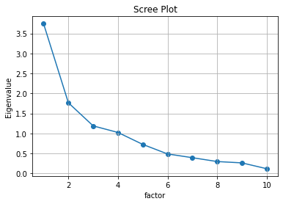

Figure 3 Scree Plot

Based on interpretation of the questions the three factors were deemed to be: neophobia, functional food characteristics and attitudes towards vegetarianism. Please see table 2 for the factor loadings regarding the variance that can be explained by the 3 variables.

Table 2 Factor analysis

|  |  |
| --- | --- |
| N = 97 | Neophobia |
| I am afraid to eat food I did not eat before. | 0.73 |
| I do not trust new food. | 0.77 |
| I constantly try new foods (reversed). | 0.50 |
| I am very particular about the food I eat. | 0.58 |
| I eat almost anything (reversed). | 0.69 |
|  | Functional food characteristics/Sensory analysis |
| Is the color of the dish appealing to you? | 0.74 |
| Do the aromas of the dish appeal to you? | 0.79 |
| Does the taste of the dish appeal to you? | 0.83 |
| Does the consistency of the dish appeal to you? | 0.88 |
|  | Attitudes towards vegetarianism |
| Vegetarians preach too much about their beliefs and eating habits | 0.98 |
| You don’t need to have a daily meal with meat for a balanced diet. | -0.47 |
|  |  |
| Cronbach’s alpha Neophobia | 0.71 |
| Cronbach’s alpha sensory analysis | 0.91 |
| Cronbach’s alpha vegetarianism | 0.83 |
|  |  |
| KMO | 0.75 |

**5. Results and Discussion**

This chapter presents the results. Section 5.1 will present the descriptive statistics summarizing characteristics found in the sample. Section 5.2 will discuss the results of the sensory characteristics questionnaire. Section 5.3 will discuss the Van Westendorp price analysis. Hereafter the conclusions will be presented.

**5.1 Descriptive statistics**

The sample comprises 97 people, who are primarily young and part of the more affluent Ugandan middle class. With an average age of 26 years and 7 months, almost half of the participants are female, on average, had 14.51 years of formal education, and who live in households of 4.2 people (table 3).

Table 3 Food neophobia and attitudes towards vegetarianism on a 5-point Likert scale ranging from 1 = strongly disagree to 5 = strongly agree

|  |  |  |  |  |
| --- | --- | --- | --- | --- |
| Characteritics(n=97) | mean | Std. dev. | min | max |
| Sociodemographic |  |  |  |  |
| Female (%) | 49% |  |  |  |
| Age (years) | 26.6 | 9.1 | 18 | 61 |
| No. household members | 4.2 | 1.80 |  |  |
| Years in formal education | 14.51 | 3.71 | 1 | 23 |
| Food Neophobia |  |  |  |  |
| I am afraid to eat food I did not eat before. | 2.40 | 1.05 | 1 | 5 |
| I do not trust new food. | 2.41 | 0.9 | 1 | 5 |
| I constantly try new foods (reversed). | 3.44 | 1.01 | 1 | 5 |
| I am very particular about the food I eat. | 3.86 | 0.75 | 1 | 5 |
| I eat almost anything (revered). | 2.92 | 1.30 | 1 | 5 |
| Attitudes towards vegeterianism |  |  |  |  |
| You don’t need to have a daily meal with meat for a balanced diet. | 3.20 | 1.21 | 1 | 5 |
| Vegetarians preach too much about their beliefs and eating habits. | 2.83 | 1.21 | 1 | 5 |

The descriptive results of participants neophobia regarding food suggest that participants are relatively open to trying new foods. With a mean average of 3.74 (4 = agree) to the question ‘I constantly try new foods”. Less than 35% of the sample agrees to the statement “I do not trust new food” and “I am afraid to eat food I did not eat before”. With regard to the statement trying to assess the attitudes towards dishes that are meat free things where mixed with a mean average of 3.20. Where 3 was neither disagree or agree and 4 was agree, the standard deviation was large being 1.21. As such a large proportion, 45%, of the respondents replied that they see daily meat consumption as imperative to a balanced diet.

**5.2 Sensory analysis**

With a mean average of 4.12 and a standard deviation of 0.86 most respondents liked the taste of the dish.

Table 4 5-point Likert scale ranging from 1 = strongly disagree to 5 = strongly agree.

|  |  |  |  |  |
| --- | --- | --- | --- | --- |
| Sensory data | mean | Std. dev. | min | max |
| Is the color of the dish appealing to you? | 3.49 | 0.85 | 2 | 5 |
| Do the aromas of the dish appeal to you? | 3.92 | 0.77 | 2 | 5 |
| Does the taste of the dish appeal to you? | 4.12 | 0.86 | 2 | 5 |
| Does the consistency of the dish appeal to you? | 4.12 | 0.90 | 2 | 5 |

On average all sensory characteristics show that the dish was liked by the respondents with all means being well above scores of 3 (“neither like or dislike”). The color of the dish received mixed results with 25% a large proportion of respondents answering they were indifferent or disliked the dish color with a mean response of 3.49 and a standard deviation of 0.85.

**5.3 Price sensitivity meter**

Each participant had to state four prices (too cheap, cheap, expensive, and too expensive). Before analyzing the price sensitivity meter, the data was cleaned. To this end participants answers where checked for plausibility and missing values. Answers regarding price had to comply with the order: too cheap > cheap > expensive > too expensive. None of the data needed to be dropped. As explained in the theoretical framework the most important price points are: the optimal price point (OPP), the indifference point, the point of marginal cheapness (PMC), and the point of marginal expensiveness (PME).

*Neutral Frame*

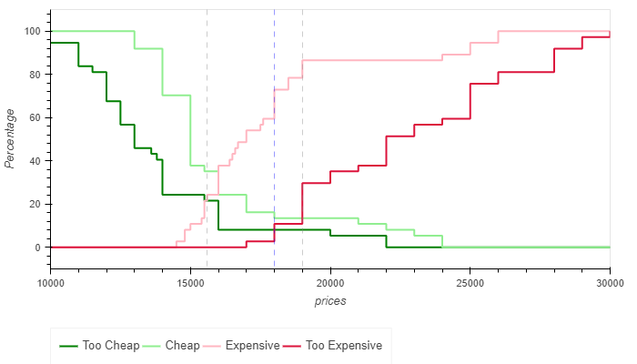Figure 5 Neutral frame

Figure 5 shows that within the neutral frame the OPP was UGX 18000 or USD 4.70, this is the point where the cumulative frequencies of participants finding the dish too cheap and too expensive is equal. The intersection of the too cheap and expensive lines delineates the point of marginal cheapness, together with the point of marginal expensiveness this gives us the acceptable price range. For the neutral frame the point of marginal cheapness was 15600 UGX or 4 USD. The point of marginal cheapness, is the price at which the same proportion of respondents experience the product as “not cheap” and “too cheap”. Secondly, the point of marginal expensiveness (PME) for the neutral frame is 1900 UGX or 4.92 USD. Which is the price at which the same proportions of respondents experience the product as “not expensive” and “too expensive”.

*Vegetarian meat free frame*

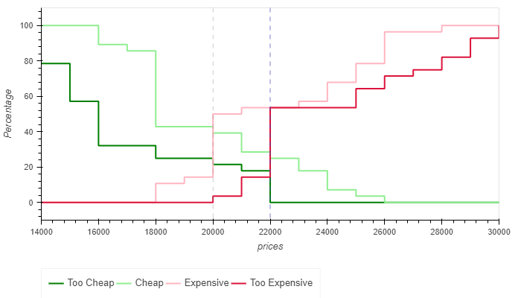

Figure 6 Vegetarian frame

Figure 6 shows that with the vegetarian meat free frame the OPP is UGX 1600 or USD 4.18. This is the price point that is optimal in terms of maximizing sales volume or market share. The acceptable price range for the vegetarian frame is in between UGX 15400 and UGX 18000 or between USD 4.02 and USD 4.70.

*Environmental frame*

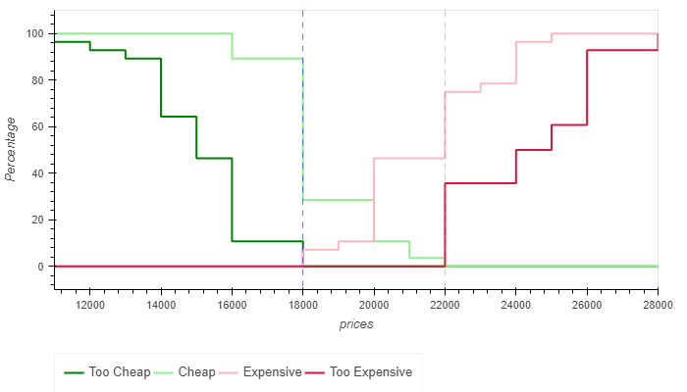

Figure 7 Environmental Frame

Figure 7 shows that with the environmental frame the OPP or the point where the cumulative frequencies of participants finding the dish too cheap and too expensive is equal for the environmental frame is UGX 18000 or USD 4.70. The acceptable price range for the environmental frame is between UGX 18000 and UGX 22000 or in USD between $4.70 and $5.80.

Regarding if the mean differences are significant, I conducted an ANOVA analysis. The null hypothesis of the ANOVA is that the differences between frames are not significant. The alternative hypothesis is that changing the framing of the menu leads to different means of the average willingness to pay.

With an F ratio of 13.514 and p being 0.000 the averages of the WTP answers differ significantly per frame. The null hypothesis therefore is rejected and the alternative hypothesis is accepted. As such it can be concluded that vegetarian and environmental frames significantly influence average WTP.

**6. Discussion and Conclusion**

The results of the study show that the participants in general are open to trying new foods. Indicating that the unfamiliarity with soy-meat does not have to be an impediment for consumers to purchase. One has to note that the participants in this study where young with an average age of 26.6 years old which might affect making general conclusions. In addition, the sensory characteristics of soy meat also seem to please the consumers that participated in the study and seem to not be an impediment for adoption of soy meats. As such there seems to be indication that consumers are willing to consume plant-based meats in their diets. To my knowledge this study is one of the first of its kind, analyzing consumer perception of plant-based meat in Uganda. As such the results have to be treated as tentative and need further validation.

Regarding the effects of framing on the willingness to pay it seems that consumers do expect to pay less for culinary dishes that are advertised as meat free. Advertising the menu by making it salient that it is meat free seems to lower the price Ugandan consumers are willing to pay for a meal. The vegetarian branding lowered the price consumers where willing to pay by 12% or 0.52 USD. Contrary to western consumers Ugandan expect to pay less for menu items that are branded as vegetarian. This has implications for the branding strategy Sesaco should implement in future marketing strategies. Somewhat surprisingly branding that made the environmental impact salient performed relatively well. It did not increase the optimal price willingness to pay compared to neutral branding. However, the acceptable price range was significantly higher. Branding emphasizing environmental impact performed better than vegetarian branding. I would advise to study the factors that affect brand awareness for Ugandan consumers. The study participants where not representative for the broader Ugandan population, being part of the more affluent middle class.

However, it seems clear that a communication strategy has to incorporate branding that it conducive to the Ugandan environment. It seems that such a branding strategy has to make different considerations from those that are employed in developed countries, and should emphasize other characteristics than being plant based in its communication to consumers. Some options are to focus on the versatility of soy meat and focus on the dish that can be prepared, economics, or nutritional profile.

# References

Aithal, R., Satyam, B., & Maurya, H. (2018). Distribution Challenges in Emerging Markets: Evaluating Alternate Distribution strategies for FMCG Firms in rural India. *Strategic Marketing issues in emerging markets*.

Anderson, J., Johnstone, B., & Cook-Newell, C. (1995). Meta-analysis of the effects of soy protein intake. *New England journal of medicine*, 276-282.

Asgar, M., Fazilah, A., Huda, N., Bhat, R., & Karim, A. (2010). Nonmeat protein alternatives that serve as meat extenders and meat analogs. *Comprehensive reviws in food science and food safety 9(5)*, 513-529.

Auma, C., Pradeilles, R., Blake, M., & Holdsworth, M. (2019). What can dietary patterns tell us about the nutrition transition and environmental sustainability of Diets in Uganda. *Nutrients*, 1-11.

Bacon, L., & Krpan, D. (2018). Bacon, L., & Krpan, D. (2018). (Not) Eating for the environment: The impact of restaurant menu design on vegetarian food choice. ,. *Appetite*, 190–200.

Barton, A., & Richardon, C. M. (2020). Consumers attitudes towards enthomophagy before and after evaluating cricket based protein powders. *Journal of food science*, 781-788.

Bryant, C. (2019). we can't keep meating like this: Attitudes to Vegeterian and vegan diets in the united kingdom. *Sustainability*, 1-17.

Bucher, T., Collins, C., Rollo, M., Mcaffrey, T., Vlieger, D. N., Bend, V. d., . . . Perez-Cueto, F. (2016). Nudging consumers towards healthier food choices: a systematic review of positional influences on food choice. *British journal of nutrition*, 1-12.

Butler, S., & Francis, S. (1997). The effects of environmental attitudes on apparel purchasing behaviour. *Clothing and textiles research journal*, 76-85.

Campbell-Arvai, V., Kalof, L., & Arvai, J. (2012). Motivating Sustainable Food Choices: The Role of Nudges, Value Orientation, and Information Provision. *Environment and behaviour*, 453-475.

Carver, J. (2007). The Use of grounded theory in empirical software engineering. *LNPSE*, 2-15.

Casey, J., Kim, B., Larsen, J., & Nachman, K. (2015). Industrial food animal production and community health. *Current Envrinmental Health rep 2*, 259-271.

Clayton, S., Devine-Wright, P., Stern, P., Whitmarsh, L., Carrico, A., & Steg, L. (2015). Psychological research and global climate change. *Nature climate change*, 640-646.

Dewey, C. (2020, July 19). The Silicon Valley Food Start-up Best Known for Its Vegan Mayo Thinks It Can cure malnutrition in Africa. *Wasington Post*.

Dror, D., & Allen, L. (2011). The importance of milk and other animal source foods for children in low income countries. *Food nutrition bullitin*, 227-243.

Entman, R. (1993). Framing: Toward clarification of a fractured paradigm. *Journal of communication 43*, 51-58\.

FAO; IFAD; WFP. (2013). *The state of Food insecurity in the world .* Rome: FAO .

Foley, J., Ramankutty, N., Brauman, K., Cassidy, E., Gerber, J., & Johnston, M. (2011). Solutions for a cultivated planet. *nature 478*, 337-342.

Halaweh, M. (2012). Using grounded theory as a method for system requirement analysis. *Journal of information systems and technology managment*, 23-38.

Hansen, T. (2008). Consumer values, the theory of planned behaviour and online grocery shopping. *International journal of consumer studies*, 128-137.

Homer, P., & Kahle, L. (1988). A structural equation test of the value-attitude-behaviour model. *Journal o personality and social psychology 54*, 683-646.

Hoppe, C., Molgaard, C., & Michealsen, K. (2006). Cow's milk and linear growth in industrialized and developing countries. *annual review of nutrition*, 131-173.

Janssen, M., & Hamm, U. (2012). Product labelling in the market for organic food: Consumer preferences and willingness to pay for different organic certification logos. *Food quality and preferences 25*, 9-22.

Kasper, C., & Ramos, I. (2013). Requirments Specifications and Recoverd architectures as Grounded Theories. *researchgate*, 1-7.

Malav, O., Talukder, S., Gokularakrishan, P., & Chand, S. (2015). Plant-based substitues a review. *Critical review of food science*, 1241-1245.

Mottet, A., Haan, d. C., Falcucci, A., Tempio, G., Opio, C., & Gerber, P. (2017). Livestock: on our plates or eating at our table? A new analysis of the feed/food debate. *Global food security 14*, 1-8.

Pelsmacker, D. P., Driesen, L., & Rayp, G. (2005). Do consumers care about ethics? Willingness to pay for fair-trade-coffee. *journal of consumer affairs,39*, 363-385.

Rabadan, A., & Bernabeu, R. (2021). A systematic review of studies using the food neophobia scale: conclusions from thirty years of studies. *Food quality and preferences*.

Santo, R., Kim, B., Goldman, S., Dutkiewicz, J., Biehl, E., Bloem, M., . . . Nachman, K. (2020). Considering plant-based meat substitutes and cell-based meats: A public health and food systems perspective. *fronteirs in suistainable food systems*, 1-23.

Schonfeldt, H., & Hall, N. (2012). *Dietary protein quality and malnutrition in Africa.* Aukland: International Symposium on Dietary Protein for Human Health.

Semba, R. D. (2016). The rise and fall of protein malnutrition in global health. *annals of nutrition and metabolism 69*, 79-88.

Sillito, J., & Wynn, E. (2007). The Social Context of Software Maintenance. *Software Maintenance.* IEEE international conference on software maintenance.

Stern, P. (2000). New environmental theories: Towards a coherent theory of environmentally significant behaviour. *Journal of Social Issues 56*, 407-424.

Stern, P. (2011). Contributions of psychology to limiting climate change. *American Psychologist*, 303-314.

Stol, K., Ralph, P., & Fitzgerald, B. (2019). Grounded Theory in Software Engineering Research: A Critical Review and Guidelines. *ICSE*, 1-13.

Szejda, K., Stumpe, M., Raal, L., & Tapscott, C. (2021). South African Consumer adoption of Plant-based and cultivated meat: a segmentation study. *fronteirs in sustainable food systems*, 1-14.

Szejda, Stumpe, Raal, & Tapscott. (2021). South African Consumer Adoption of Plant-Based and Cultivated Meat: A Segmentation Study. *Fronteirs in nutrition and sustainable diets*.

Tang, J., Wan, Y., Zhao, M., Zhong, H., Zheng, J., & Feng, F. (2020). Legume and soy intake and risk of type 2 diabetes: A systematic review and meta analysis of prospective cohort studies. *American journal of clinical nutrition*, 677-688.

Thaler, R., & Sunstein, C. (2008). *Nudge: improving decisions about health, welath and hapiness.* New Haven: Yale university press.

Thompson, B., & Meerman, J. (2013). *Narrowing the nutrition gap: investing in agriculture to improve dietary diversity.* Rome: WHO.

Turnwald, B., Jurafsky, D., Conner, A., & Crum, A. (2017). Reading between the menu lines: are restaurants descriptions of healthy foods unappealing. *Health and psychology*, 1216-1218.

UN Intergovernmental Panel on Climate Change. (s.d.). *Special report: global warmin of 1.5 degrees .*

Vanderbroele, J., Vermeir, I., Guens, M., Slabbinck, H., & Kerckhove, V. A. (2019). Nudging to get our food choices on a sustainable track. *Proceedings of the nutrition society*, 1-15.

Verplanken, B., & Holland, R. (2002). Motivated decision making: Effects of activation and self-centrality of values on choices and behaviour. *Journal of Personality and Social psychology 82*, 434-447.

Visschers, V., & Siegrist, M. (2015). Does better for the environment mean less tasty? Offering more climate friendly meals is good for the environment and customer satisfaction. *Appetite*, 475-483.

Wansink, B., & Sobal, J. (2007). Mindless Eating. *Environment and behavior*, 106-123.

Wei, S., Ang, T., & Jancenelle, V. (2018). Willingness to pay more for green products: the interplay of consumer characteristics and consumer participation. *journal of retaling and consumers*, 230-238.

Weinrich, R., & Gassler, B. (2021). Beyond classical van westendorp: Assessing price sensitivity for variants of algea based meat substitutes. *journal of retailing and consumer services*.

Willett, W., Rockström, J., Loken, B., Springmann, M., Lang, T., Vermeulen, S., . . . Wood. (2019). Food in the Anthropocene: The EAT-lancet Commission on healthy diets from sustainable food systems. *Lancet*, 447-492.

Young, V. (1991). Soy protein in relation to human protein and amino acid nutrition. *pubmed*, 828-835.

Zhang, G., Zao, X., Du, G., Zhou, J., & Chen, J. (2020). Challenges and possibilities for bio-manufacturing cultured meat. *Trends in food science Technology*, 443-450.

**Appendix 1 Questionnaire**

Sociodemographic

What is your age:

Sex:

Male – Female:

No. of people living in your household:

Food Neophobia

I am afraid to eat food I did not eat before:

1 = strongly disagree, 2= slightly disagree, 3 = neutral, 4 = slightly agree,5 = strongly agree

I do not trust new food

1 = strongly disagree, 2= slightly disagree, 3 = neutral, 4 = slightly agree,5 = strongly agree

I constantly try new foods (reversed)

1 = strongly disagree, 2= slightly disagree, 3 = neutral, 4 = slightly agree,5 = strongly agree

I am very particular about the food I eat

1 = strongly disagree, 2= slightly disagree, 3 = neutral, 4 = slightly agree,5 = strongly agree

I eat almost anything (reversed)

1 = strongly disagree, 2= slightly disagree, 3 = neutral, 4 = slightly agree,5 = strongly agree

Attitudes towards vegetarianism

Vegetarians preach too much about their beliefs and eating habits

1 = strongly disagree, 2= slightly disagree, 3 = neutral, 4 = slightly agree,5 = strongly agree

You don’t need to have a daily meal with meat for a balanced diet.

1 = strongly disagree, 2= slightly disagree, 3 = neutral, 4 = slightly agree,5 = strongly agree

Sensory evaluation

Is the color of the dish appealing to you?

1= dislike very much, 2= slightly dislike, 3 = indifferent, 4 = slightly like, 5 = like very much

Do the aromas of the dish appeal to you?

1= dislike very much, 2= slightly dislike, 3 = indifferent, 4 = slightly like, 5 = like very much

Does the taste of the dish appeal to you?

1= dislike very much, 2= slightly dislike, 3 = indifferent, 4 = slightly like, 5 = like very much

Does the consistency of the dish appeal to you?

1= dislike very much, 2= slightly dislike, 3 = indifferent, 4 = slightly like, 5 = like very much

**Appendix 2 Price sensitivity analysis**

In [ ]:

**import** pandas **as** pd **import** hvplot.pandas **import** holoviews **as** hv

prices **=** pd**.**read_csv('C:/Users/socie/OneDrive/Documents/thesis 1 and 2/thesis 2/data prices1 **=** prices**.**drop(['index','Frame'], axis **=**1, inplace**=True**)

prices2 **=** pd**.**read_csv('C:/Users/socie/OneDrive/Documents/thesis 1 and 2/thesis 2/dat

prices3 **=** prices2**.**drop(['index','Frame'], axis **=**1, inplace**=True**)

prices4 **=** pd**.**read_csv('C:/Users/socie/OneDrive/Documents/thesis 1 and 2/thesis 2/dat prices5 **=** prices4**.**drop(['index','Frame'], axis **=**1, inplace**=True**)

df **=** pd**.**DataFrame(prices) df1 **=** pd**.**DataFrame(prices2) df2 **=** pd**.**DataFrame(prices4)

In [17]:

**def** price_sensitivity_meter(df, interpolate**=False**):

*# convert data from wide to long*

*# calculate frequency of each price for each group*

df1 **=** (df[['Too Cheap', 'Cheap', 'Expensive', 'Too Expensive']]

**.**unstack()

**.**reset_index()

**.**rename(columns **=** {'level_0':'label', 0: 'prices'})[['label','prices']]

**.**groupby(['label','prices'])

**.**size()

**.**reset_index()

**.**rename(columns **=** {0: 'frequency'})

)

*# calculate cumsum percentages*

df1['cumsum'] **=** df1**.**groupby(['label'])['frequency']**.**cumsum()

df1['sum'] **=** df1**.**groupby(['label'])['frequency']**.**transform('sum') df1['percentage'] **=** 100**\***df1['cumsum']**/**df1['sum']

*# convert data from long back to wide*

df2 **=** df1**.**pivot_table('percentage', 'prices', 'label')

*# take linear values in missing values*

**if** interpolate:

df3 **=** df2**.**interpolate()**.**fillna(0) df3['Too Cheap'] **=** 100 **-** df3['Too Cheap'] df3['Cheap'] **=** 100 **-** df3['Cheap']

plot **=** df3**.**hvplot(x**=**'prices',

y**=**['Too Cheap', 'Cheap', 'Expensive', 'Too Expensive'], ylabel **=** 'Percentage',

height**=**400,

color**=**['green','lightgreen','lightpink','crimson']

)**.**opts(legend_position**=**'bottom')

*# forward fill*

**else**:

df3 **=** df2**.**ffill()**.**fillna(0)

df3['Too Cheap'] **=** 100 **-** df3['Too Cheap'] df3['Cheap'] **=** 100 **-** df3['Cheap']

plot **=** df3**.**hvplot**.**step(x**=**'prices',

y**=**['Too Cheap', 'Cheap', 'Expensive', 'Too Expensive' where**=**'post',

ylabel **=** 'Percentage', height**=**400,

color**=**['green','lightgreen','lightpink','crimson']

)**.**opts(legend_position**=**'bottom') df3['optimal_diff'] **=** (df3['Too Cheap'] **-** df3['Too Expensive']) df3['left_diff'] **=** (df3['Too Cheap'] **-** df3['Expensive']) df3['right_diff'] **=** (df3['Too Expensive'] **-** df3['Cheap']) optimal **=** df3[df3['optimal_diff']**<=**0]**.**index[0]

lower_bound **=** df3[df3['left_diff']**<=**0]**.**index[0] upper_bound **=** df3[df3['right_diff']**>=**0]**.**index[0]

optimal_line **=** hv**.**VLine(optimal)**.**opts(color**=**'blue', line_dash**=**'dashed', line_wid

lower_line **=** hv**.**VLine(lower_bound)**.**opts(color**=**'grey', line_dash**=**'dashed', line_w upper_line **=** hv**.**VLine(upper_bound)**.**opts(color**=**'grey', line_dash**=**'dashed', line_w

print(f'Optimal Price: ${optimal}')

print(f'Acceptable Price Range: ${lower_bound} to ${upper_bound}')

**return** plot **\*** lower_line **\*** optimal_line **\*** upper_line

In [18]:

price_sensitivity_meter(df)

Optimal Price: $18000

Acceptable Price Range: $15600 to $19000

Out[18]:

In [19]:

price_sensitivity_meter(df1)

Optimal Price: $16000

Acceptable Price Range: $15400 to $18000

Out[19]:

In [20]:

price_sensitivity_meter(df2)

Optimal Price: $18000

Acceptable Price Range: $18000 to $22000

**Appendix 3 Factor analysis**



**Appendix 4 Questionnaire analysis**

09/12/2022 15:14 questionnaire analysis



In [24]:

**import** pandas **as** pd0

**import** numpy **as** np0

**import** pingouin **as** pg0

**import** matplotlib.pyplot **as** plt0

0

df **=** pd**.**read_csv (r'C:\Users\socie\OneDrive\Documents\thesis 1 and 2\thesis 2\data\a df4 **=** pd**.**read_csv (r'C:\Users\socie\OneDrive\Documents\thesis 1 and 2\thesis 2\data\ 0

df1 **=** pd**.**DataFrame(df)0

0

df1**.**drop(['index', 'age','sex'], axis**=**1, inplace**=True**)

0

df4**.**drop(['index', 'age', 'sex', 'no. people in houshold','5','8','9','10','11'], ax

0

0

print(df1**.**describe())0

0

pg**.**cronbach_alpha(data**=**df1)0

Out[24]:

In [23]:

* 20 count 97.000000 97.0000000

mean2.835052 3.1752580

std1.213470 1.2333080

min1.000000 1.0000000

25%2.000000 2.0000000

50%3.000000 3.0000000

75%4.000000 4.0000000

max 5.000000 5.0000000 (-0.06015815534698099, array([-0.585, 0.291]))



pg**.**cronbach_alpha(data**=**df4)0

Out[23]:

In [12]:

In [13]:

Out[13]:

In [ ]:

(0.22204340921122245, array([-0.045, 0.439]))



df3 **=** pd**.**read_csv (r'C:\Users\socie\OneDrive\Documents\thesis 1 and 2\thesis 2\data\

0

0

df2 **=** pd**.**DataFrame(df3)0

df2**.**drop(['index'], axis**=**1, inplace**=True**)0

0

print(df2**.**describe())0

|  |  |  |  |  |
| --- | --- | --- | --- | --- |
|  | 1 | 2 | 3 | 40 |
| count | 97.000000 | 97.000000 | 97.000000 | 97.0000000 |
| mean | 3.494845 | 3.917526 | 4.123711 | 4.1237110 |
| std | 0.751716 | 0.772848 | 0.869120 | 0.9043610 |
| min | 2.000000 | 2.000000 | 2.000000 | 2.0000000 |
| 25% | 3.000000 | 4.000000 | 4.000000 | 4.0000000 |
| 50% | 4.000000 | 4.000000 | 4.000000 | 4.0000000 |
| 75% | 4.000000 | 4.000000 | 5.000000 | 5.0000000 |
| max | 5.000000 | 5.000000 | 5.000000 | 5.0000000 |



pg**.**cronbach_alpha(data**=**df2)0

(0.9113408209919491, array([0.879, 0.937]))



**Appendix 5 Anova**

Entrée [2]:



**import** pandas **as** pd

**from** numpy **import** repeat

**from** pingouin **import** anova, rm_anova, mixed_anova, print_table

*# Load dataset*

df **=** pd.read_csv('C:/Users/socie/OneDrive/Documents/thesis 1 and 2/thesis 2/data/data quali

*# ONE-WAY ANOVA*

aov **=** anova(dv**=**'12', between**=**['Frame'], data**=**df, detailed**=False**)

print_table(aov, floatfmt**=**".3f")

=============0

ANOVA SUMMARY0

=============0

|  |  |  |  |  |  |
| --- | --- | --- | --- | --- | --- |
| Source | ddof1 | ddof2 | F | p-unc | np20 |
| -------- | ------- | ------- | ------ | ------- | -----0 |
| Frame | 2 | 94 | 13.514 | 0.000 | 0.2230 |